**CS350 Architecture Design Presentation idea**

2022-11-08

What is architecture design?

Designing By Weaving Together Requirements and Architecture

Then what is software architecture?

Design decisions for system’s functionalities and qualities

Can verify desired functionalities and qualities

Provides development plan

set of significant decisions about the organization of a software system, the selection of 1) the structural elements and their interfaces by which the system is composed, together with 2) their behavior as specified in the collaborations among those elements, the composition of these structural and behavioral elements into progressively larger subsystems, and 3) the architectural style that guides this organization -these elements and their interfaces, their collaborations, and their composition"

What are the important points for architecture design?

Structural elements and their interfaces

Collaboration behavior among elements

The architectural style that guides this organization

What is architectural style?

Structural elements and their interfaces

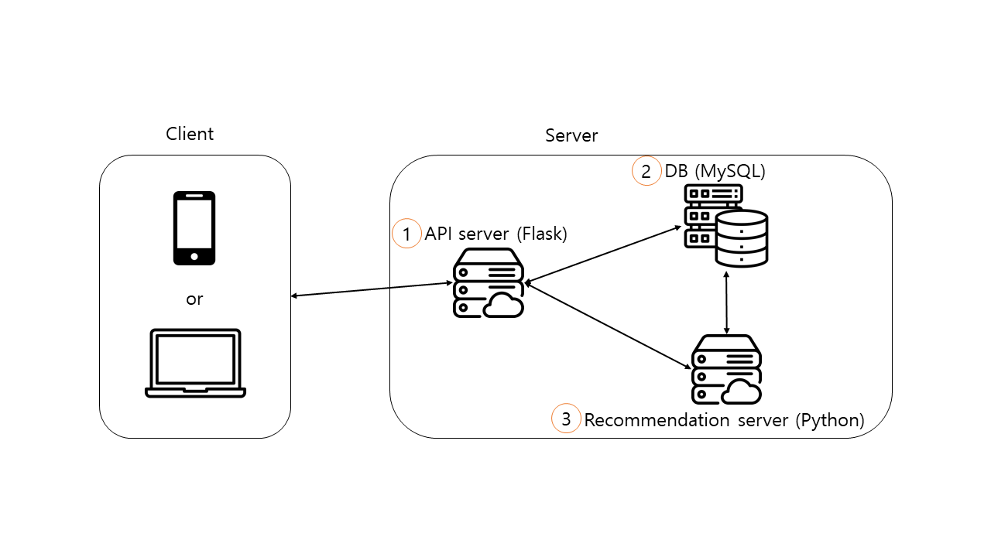

1. API server (Flask)
   1. Input
      1. API server (requests with REST API) -> Client (responds with JSON)
         1. POST login
         2. GET tododata
         3. PUT tododata
         4. GET recommendation
         5. POST logout
         6. DELETE account
   2. Output
      1. API server (requests with SQL query) -> DB (responds with data)
         1. SELECT/INSERT/UPDATE
      2. API server (requests with string through socket call) -> Recommendation server (responds with string data through socket)
         1. Get recommendation
2. DB (MySQL)
   1. Input
      1. API server (requests with MySQL query) -> DB (responds with data)
         1. SELECT/INSERT/UPDATE
      2. Recommendation system (requests with SQL query) -> DB (responds with data)
         1. SELECT
3. Recommendation System (Python)
   1. Input
      1. API server (requests with string through socket) -> Recommendation system (responds with string data through socket)
         1. Get recommendation
   2. Output
      1. Recommendation system (requests with SQL query) -> DB (procedure call: SQL query -> data)
         1. SELECT

Collaboration behavior among elements

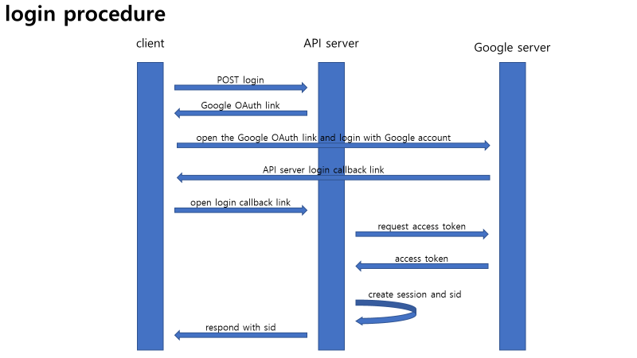

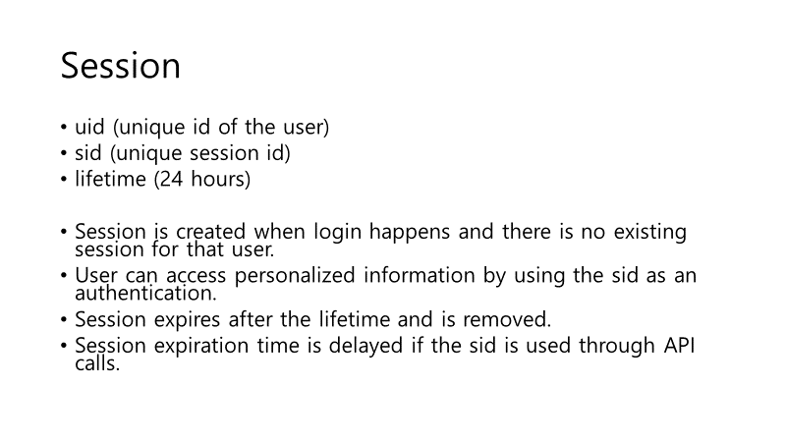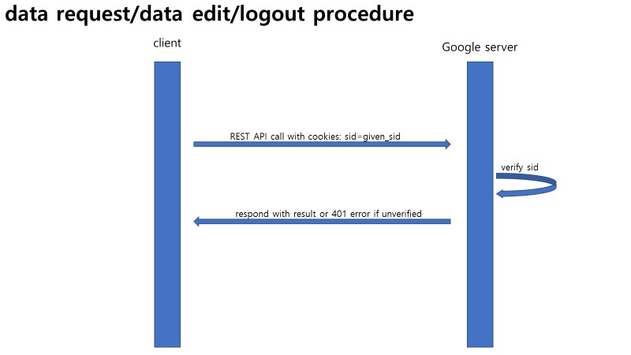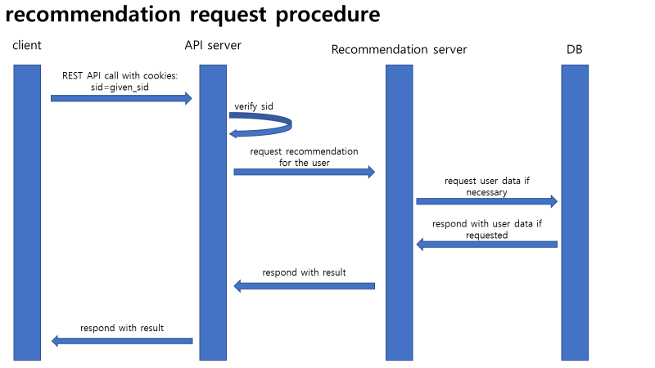

The architectural style guide that guides this organization

Layer architecture pattern is used as our architecture style guide.

In this architecture pattern, each layer is a set of modules. Due to information hiding, this pattern has the advantage of high modularity. However, the communication overhead between and within the layers could slow down the software if there are too many layers. Since we have only 3 layers and a high modularity can enhance the development speed, the layer pattern seems appropriate for our software.

